**Station #1:**

**The Five Food Groups**

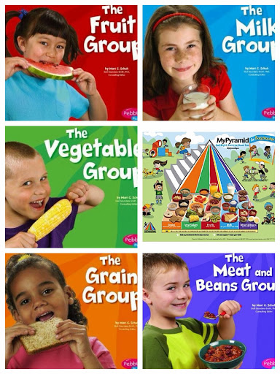

**Station #2:**

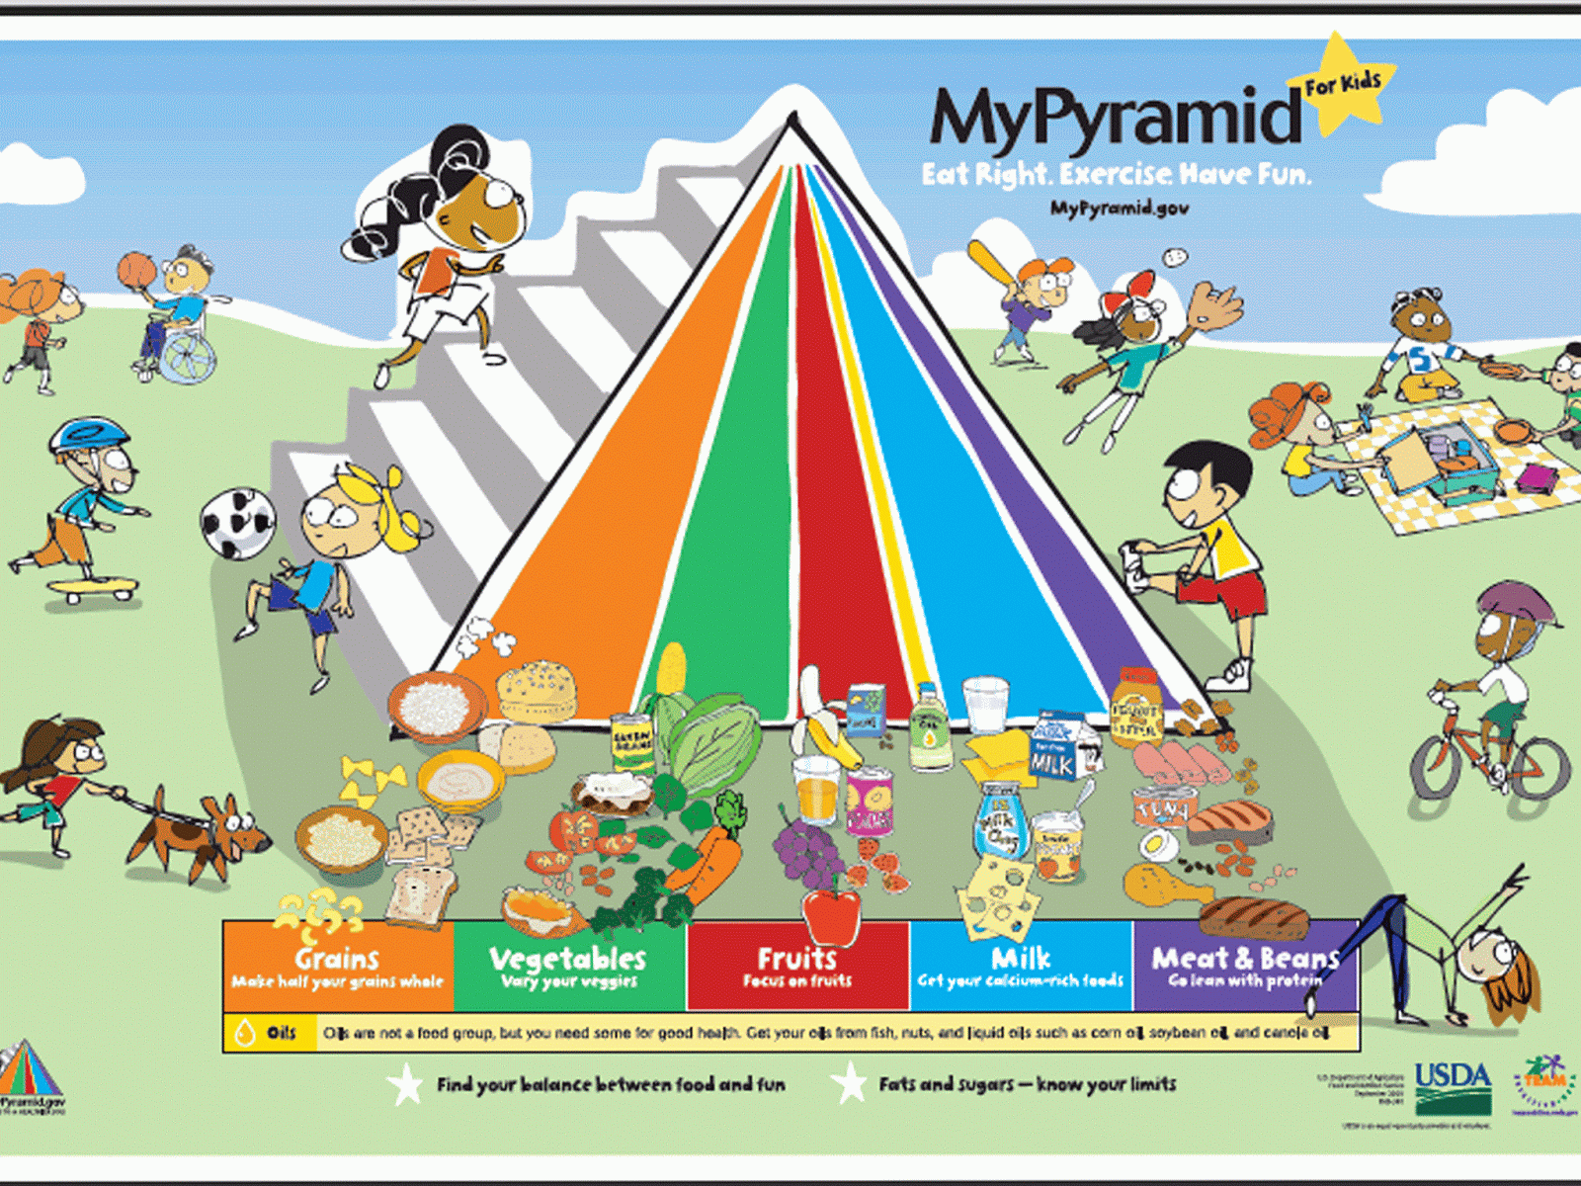**The Food Pyramid**

**Station #3:**

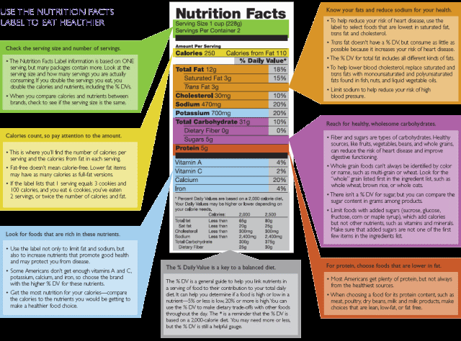**Reading Nutrition Labels**

**Station #4:**

**ChooseMyPlate**

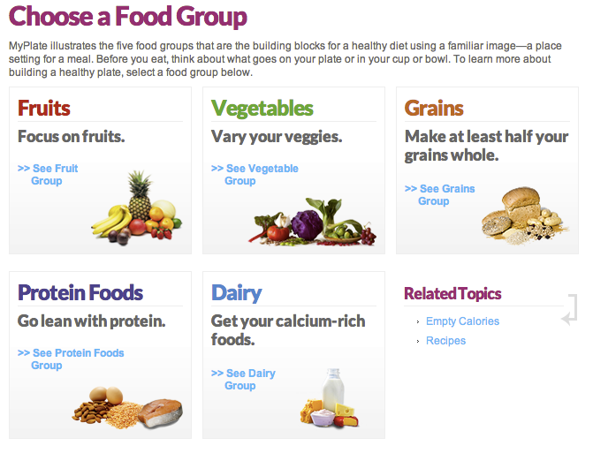

**Station #5:**

**Nutrition Games**

