Picture

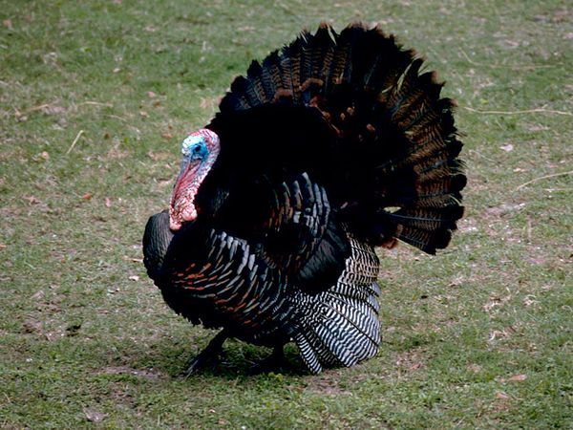

Picture



Picture



Picture



Picture



Picture

