Fairy Tales & Fables Stations

Station 1 or 6: Fractured vs. Classic Fairy Tale

Fractured Title: ________________________ Classic Title: _________________________

1.
2.
1.
2.
1.
Fractured
Classic
Same

Station 2 or 5: Fable Moral Lesson

The moral lesson in _____________________________________ is ______________________

_____________________________________________________________________________

____________________________________________________________________________.

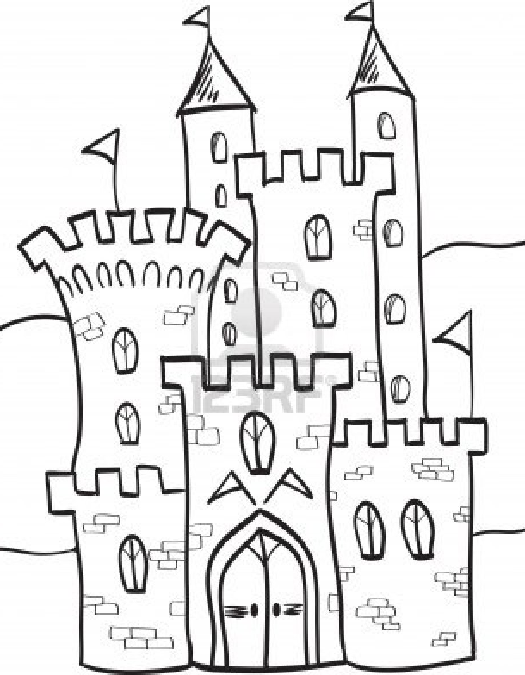
Station 3 or 4:Fairy Tale Story Elements
Solution
Characters
Problem
Setting

