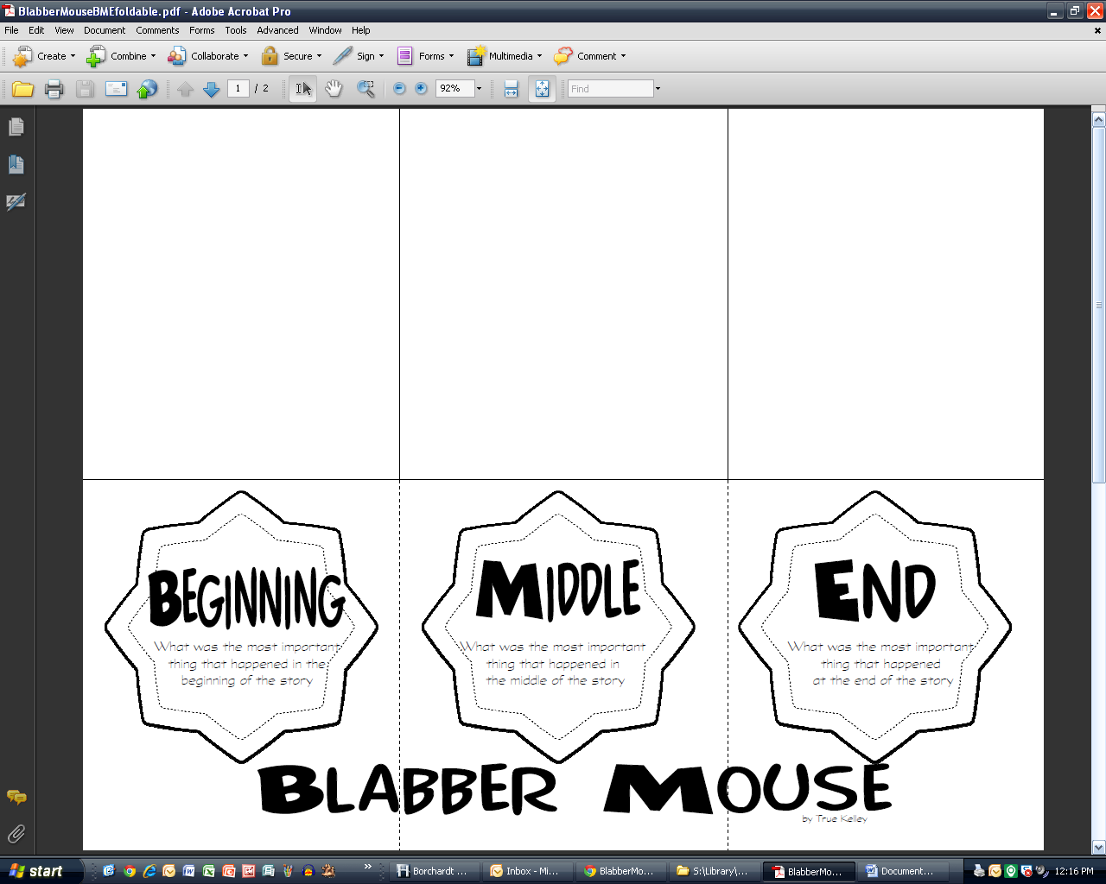

**Goldilocks and the Three Dinosaurs**