Great Books Station
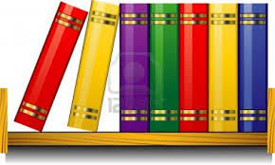
At this RBE Library Station, you will recommend books to others by creating a book spine. The book you recommend should be one that you have just read.
Directions:
- Write the title AND author on the colored paper strips using crayons or markers from the tables.
- Then take one of the white CALL NUMBER stickers and write the CALL NUMBER in BLACK.
- When your Great Book spine is done, add it to the “To Be Shelved Bucket” and we will put it on the right recommendation shelf poster.

Great Books Supplies

To Be Shelved
(Completed Book Spines)

