***C:\Documents and Settings\snyderk\Local Settings\Temporary Internet Files\Content.IE5\BLKSX438\MC900019342[1].wmf Money Counts in the Library***

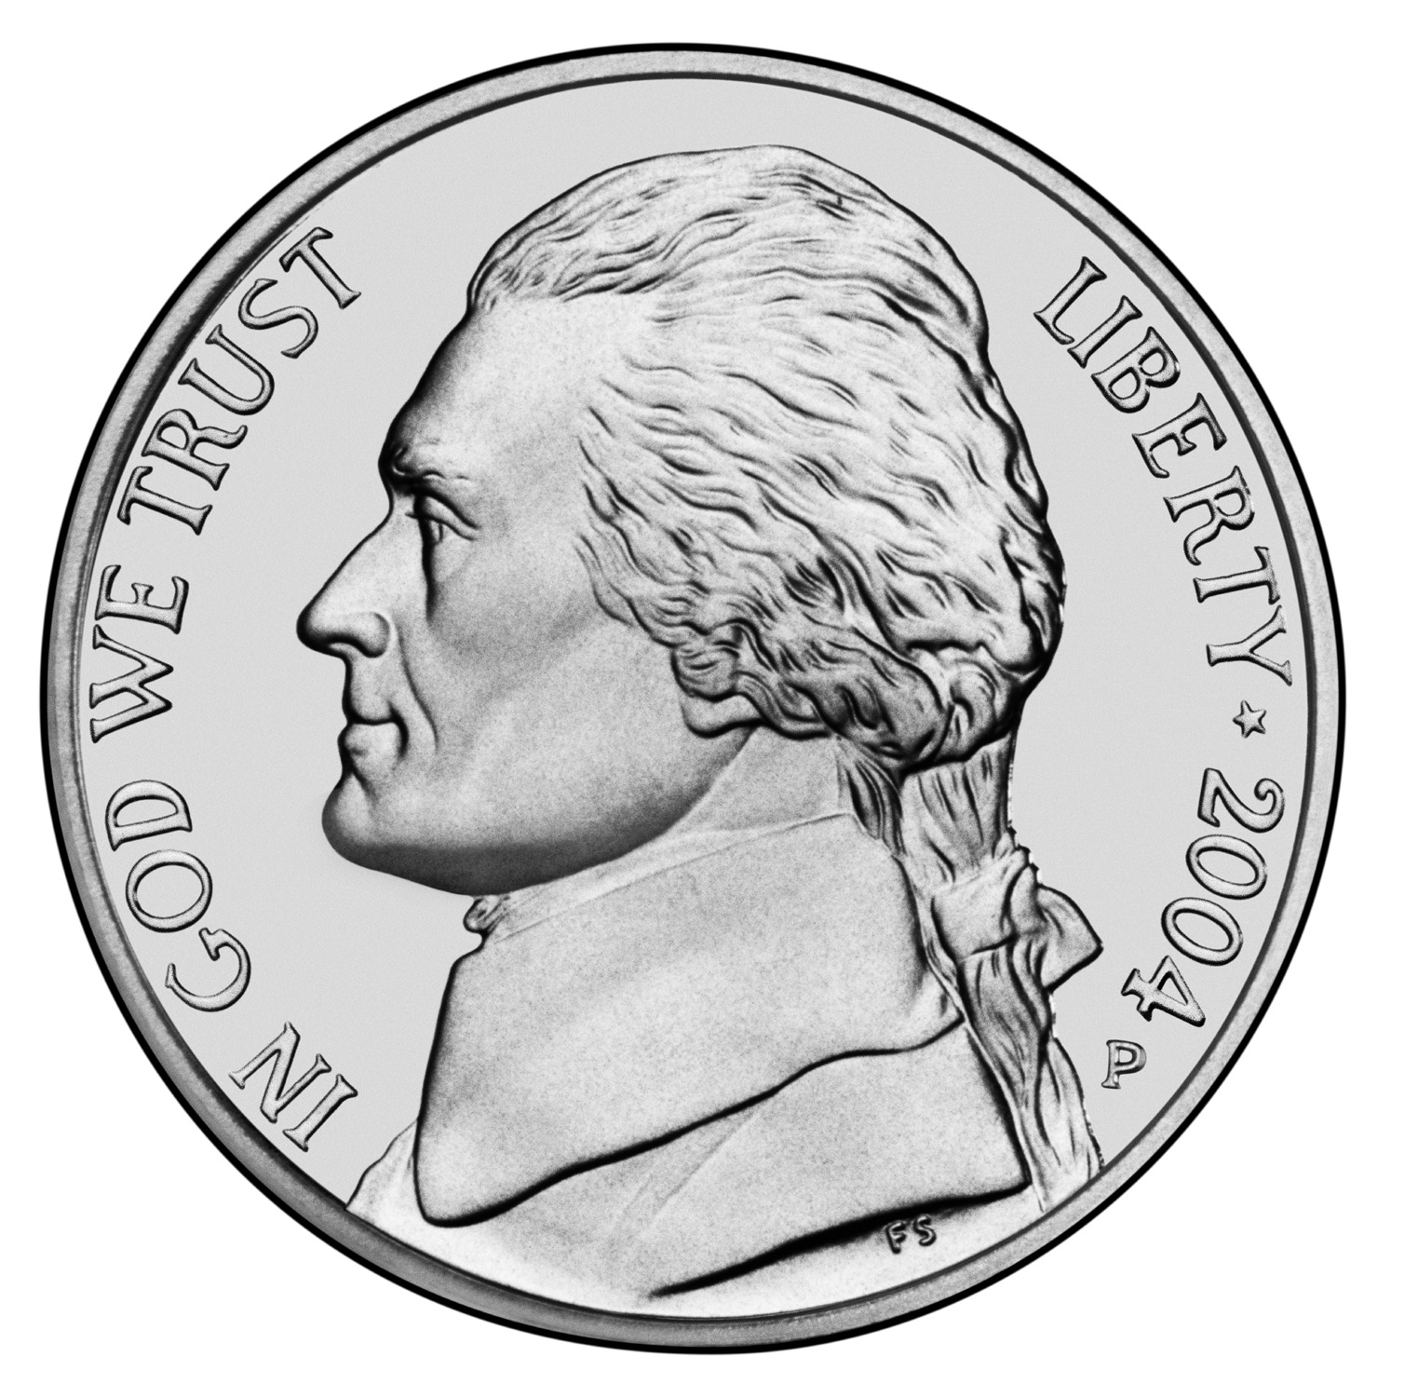**Fiction (F) = 1 cent**

**Nonfiction (###) = 5 cents**

**Everybody (E) = 10 cents**

**Biography (B) = 25 cents**

***C:\Documents and Settings\snyderk\Local Settings\Temporary Internet Files\Content.IE5\BLKSX438\MC900019342[1].wmf Money Counts in the Library***

**Fiction (F) = 1 cent**

**Nonfiction (###) = 5 cents**

**Everybody (E) = 10 cents**

**Biography (B) = 25 cents**

***C:\Documents and Settings\snyderk\Local Settings\Temporary Internet Files\Content.IE5\BLKSX438\MC900019342[1].wmf Money Counts in the Library***

**Fiction (F) = 1 cent**

**Nonfiction (###) = 5 cents**

**Everybody (E) = 10 cents**

**Biography (B) = 25 cents**

***C:\Documents and Settings\snyderk\Local Settings\Temporary Internet Files\Content.IE5\BLKSX438\MC900019342[1].wmf Money Counts in the Library***

**Fiction (F) = 1 cent**

**Nonfiction (###) = 5 cents**

**Everybody (E) = 10 cents**

**Biography (B) = 25 cents**

***C:\Documents and Settings\snyderk\Local Settings\Temporary Internet Files\Content.IE5\BLKSX438\MC900019342[1].wmf Money Counts in the Library***

**Fiction (F) = 1 cent**

**Nonfiction (###) = 5 cents**

**Everybody (E) = 10 cents**

**Biography (B) = 25 cents**

***C:\Documents and Settings\snyderk\Local Settings\Temporary Internet Files\Content.IE5\BLKSX438\MC900019342[1].wmf Money Counts in the Library***

**Fiction (F) = 1 cent**

**Nonfiction (###) = 5 cents**

**Everybody (E) = 10 cents**

**Biography (B) = 25 cents**

***C:\Documents and Settings\snyderk\Local Settings\Temporary Internet Files\Content.IE5\BLKSX438\MC900019342[1].wmf Money Counts in the Library***

**Fiction (F) = 1 cent**

**Nonfiction (###) = 5 cents**

**Everybody (E) = 10 cents**

**Biography (B) = 25 cents**

***C:\Documents and Settings\snyderk\Local Settings\Temporary Internet Files\Content.IE5\BLKSX438\MC900019342[1].wmf Money Counts in the Library***

**Fiction (F) = 1 cent**

**Nonfiction (###) = 5 cents**

**Everybody (E) = 10 cents**

**Biography (B) = 25 cents**