Shadows Discovery Stations
Station 1
Read the pages marked in The Illuminating World of Light with Max Axiom and fill in the blanks.
1. Light interacts with different __________________ in different ways.
2. Clear glass is ________________. Light passes ________________ transparent objects.
3. But objects like this painting are __________________. Light can’t pass through _________________ objects.
4. Because opaque objects ___________________ light, we see _________________ or dark spots behind them.
Station 2
Read the World Book Online Shadow Article and fill in the blanks.

5. A shadow is the darkness where an object _______________ light.

6. ________________ use shadows to tell time.

Read the All About Light book and fill in the blanks.

7. Wherever you go, you will have a _______________ because the sunlight cannot pass through your body.

8. No, shadows change as the ____________________ of the source of light changes.

Station 3
Shadow Hand Puppets Observation
As you move your hands around at this station and create hand shadow puppets, make 2 observations about shadows and light and record them here.

9.____________________________________________________________________________

10.___________________________________________________________________________
Station 4
Complete the bar graph at this station for the size of a shadow and answer the questions below.
11. Describe how the size of the shadow changed as the object moved closer to the light.
_____________________________________________________________________________
12. What did you notice about the darkness and shape of the shadow as the object moved closer to the light source.

_____________________________________________________________________________

Station 5
Read from the pages marked in How Does Science Work: Exploring Light and fill in the blanks.
13. The sun does ________________ move, it just looks like it does.
For 14-16, Sketch the shadow as the sun moves during the day
14. 15. 16.
Night
Noon
Morning
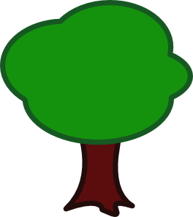

Station 6
Read World Book Online Sundial Article and fill in the blanks.
17. The ____________________ is the oldest known tool for measuring time.
18. It uses __________________ cast by the sun.
19. These shadows change as the sun moves across the ___________________.
20. The length or angle of the shadow tells the ___________________.

