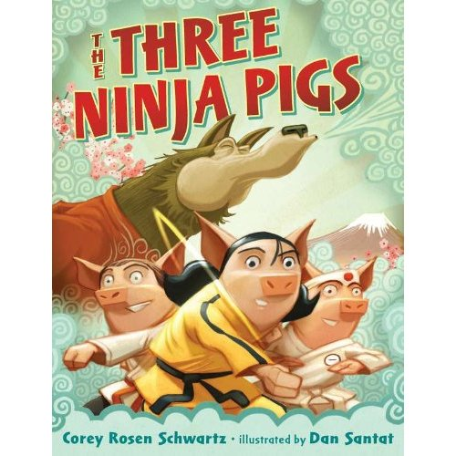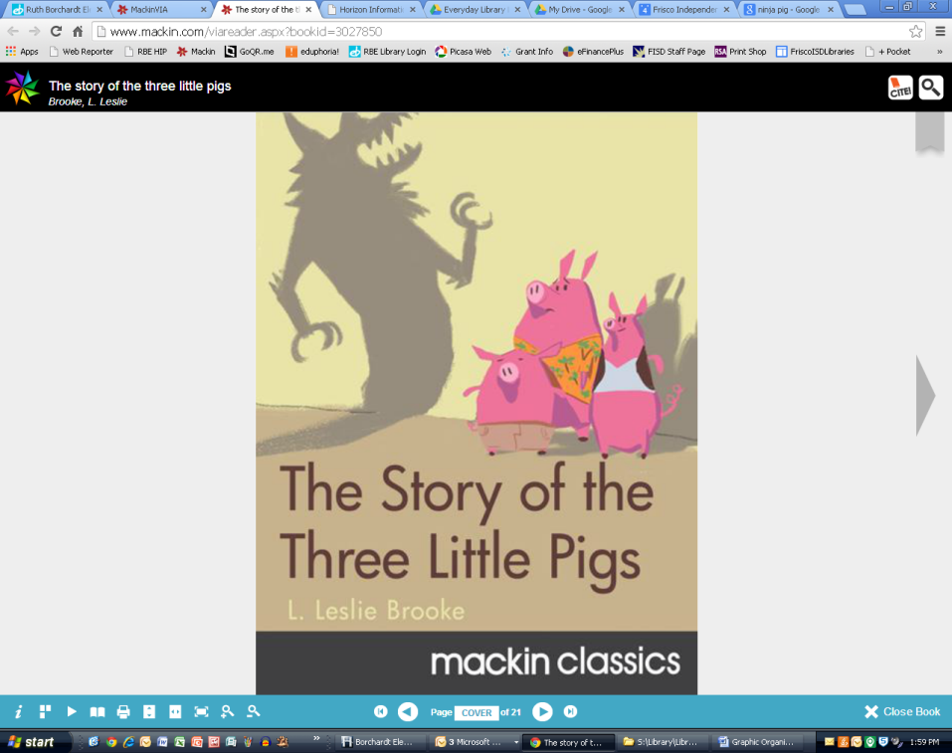

**My connections to Story 2:**

**____________________________________**

**____________________________________**

**____________________________________**

**____________________________________**

**____________________________________**

**What I like about both stories:**

**____________________**

**____________________**

**____________________**

**____________________**

**____________________**

**____________________**

**My connections to Story 1:**

**____________________________________**

**____________________________________**

**____________________________________**

**____________________________________**

**____________________________________**

**Characters 2**

**Characters 1**

**Story 2 _____________________________**

**Setting 1**

**Story 1 _____________________________**

**Both Stories**

**Plot 1**

**Setting 2**

**Plot 2**