Here are some questions I asked as I read:

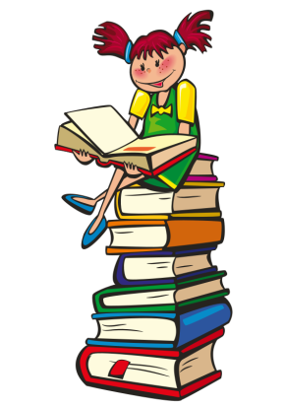

I can listen to stories!
Title: _________________________________________________
This book was:
Good Bad

Here is a picture from the story:

