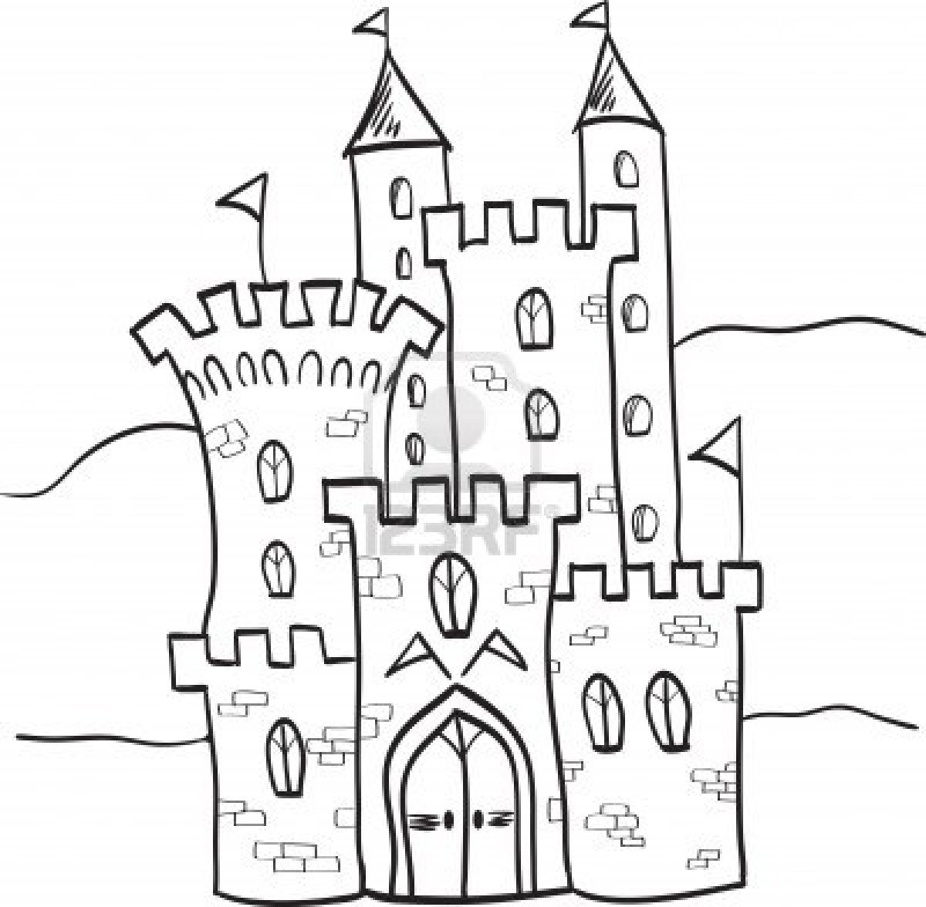Fairy Tale Story Elements

**Characters**

**Solution**

**Problem**

**Setting**