Media Literacy Reading Response
Documentary | Magazine Ad
TV News | Website

Directions: List the tools that are used in these types of media. Be sure to glue this into your reader’s response journal.

Media Literacy Reading Response
Media Literacy Tools

Directions: List the tools that are used in these types of media. Be sure to glue this into your reader’s response journal.

Media Literacy Reading Response
- Circle 3 examples of good capitalization.

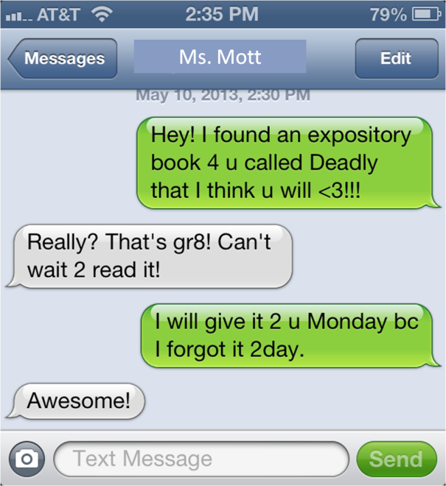
- Circle 3 examples of shortened words or numbers used instead of the actual words.

- In looking at these 2 examples of digital media, explain why the White House used good capitalization and punctuation and why Ms. Mott and Mrs. Lambert did not in their texts.

______________________________________________________________

______________________________________________________________

______________________________________________________________

